Meeting God in Worship - Part 1
Encountering the Presence of God in Worship – Isaiah 6:1-8

Objectives

1 – Examine what the Bible teaches about worship
2 – Deepen our relationship with God through our worship
3 – Respond to God in greater ways

Isiah 6:1-8

An example of a Biblical worship experience

Process of worship

1 – The revelation of God

2 – The realization of God’s holiness

3 – The recognition of our own sinfulness

4 – A renewed perspective

5 – A response

Applications

1 – Spend time in worship each day

2 – Listen to worship music

3 – Hide God’s Word in your heart

4 – Ask God to search your heart

5 – Keep an open heart to respond to God

Meeting God in Worship - Part 2
Encountering the Power of God in Worship – 1 Kings 18

Three Observations

1 – Worship was the issue at Mt. Carmel
2 – The people encountered the power of God
3 – They responded in worship

Four Concepts

1 – Relationship

2 – Repentance

3 – Rulership

4 – Renewal

1 – It brings a new perspective
2 – It brings a desire to obey
3 – It helps us see God’s sovereignty
4 – It gives us rest
5 – It brings us power

When God’s power is released, we experience:

1 – An authentic sense of God’s presence
2 – Conviction
3 – Deliverance
4 – Strength
5 – A sensitivity to His voice
6 – An eternal perspective
Meeting God in Worship - Part 3
Expressing Our Worship to God– Hebrews 13:11-16

Objectives

1 – Examine what the Bible teaches about worship
2 – Deepen our relationship with God through our worship
3 – Respond to God in greater ways

Pattern of Worship

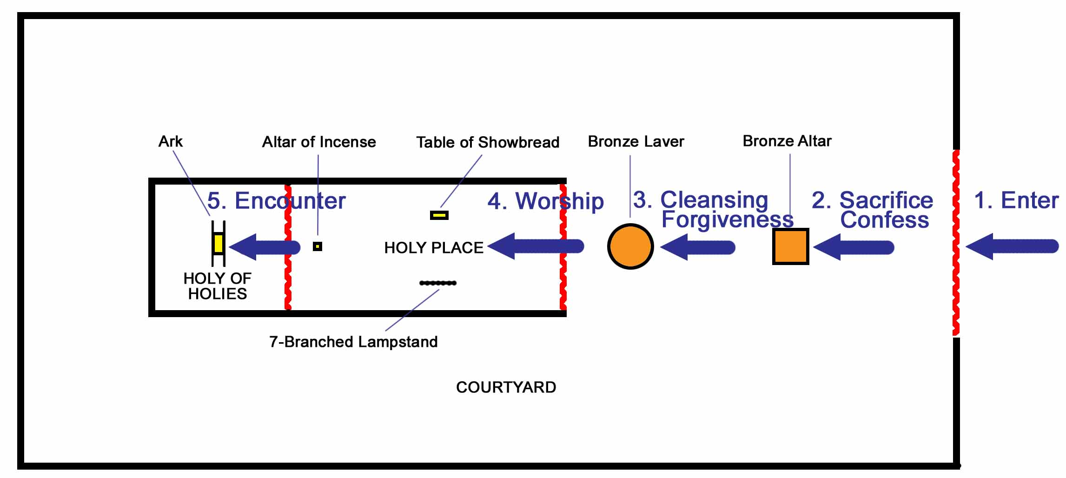

The priority of Worship
The preparation for worship
The practice of worship
The product of worship

Jesus’ death on the cross…
…fulfilled the Law

…removed the barrier

…provided intimacy with the Father

Our praise is to be…
…continual

…sacrificial

….audible
Meeting God in Worship - Part 4
Don’t Miss the Gathering – Hebrews 10:19-25

Introduction:

Corporate worship is important…

…because it reminds us of the work of Christ

…because if affects key areas of our lives

We re-orient our faith

We restore our hope

We resolve to love

Meeting God in Worship - Part 5
Enjoying God in Worship – John 12:1-26

Introduction:

Mary (1-11)

- Risk

- Extravagance

The Crowds (12-19)

- Personal not private

Personal
Reverence
Appreciative
Illuminating
Sincere
Enthusiastic

The Greeks (20-26)

- Seeking

- Teachable

- Unashamed

